What is the key difference between traditional virtualization and cloud?

Hypervisors

Commercial virtualization software

**Orchestration**

Abstraction

Which of the following is *not* a key potential benefit of cloud

computing:

Agility

Resiliency

**Compliance**

Economics

What business benefit(s) was Amazon attempting realize when they created their internal cloud computing program? Select all that apply.

**Faster time deploy developer resources**

Build a world-class public cloud computing platform

**Better match real-time capacity fluctuating demand**

Beat Microsoft

Resource pools permanently assign resources ta user.

True

**False**

Cloud computing supports scaling up of required resources, but not

scaling down.

True

**False**

**Which of the following appear in both the NIST and ISO/IEC cloud computing definitions? Check all**

Services scaling out and scaling in quickly are an example of which essential characteristic of cloud.

Resource Pooling

On-Demand Self Service

**Rapid Elasticity**

Measured Service

Broad Network Access

Which of the following is not an emergent property of resource

pooling?

Governance

Isolation

Segmentation

**Broad Network Access**

Which service model would a cloud database be considered?

Storage as a Service

**Platform as a Service**

Software as a Service

Infrastructure as a Service

Software as a Service is always built on top of Platform as a Service which is always built on Infrastructure as a Service.

True

**False**

Which of the following is most likely tbe considered laas:

OA container registry

OA cloud message queue

The cloud's management console

OA **virtual machine**

In laas , individual virtual machines use which kind of storage?

VSTOR-based hardware

OA database platform

The local hard drives on the servers

**Virtual volumes from a storage pool**

Platform as a Service abstracts application platforms and platform components from underlying resources, and can be built on top of

IaaS.

**True**

False

Which of the following is not required tbe considered SaaS?

Underlying physical hardware

**Customer management of the underlying resources**

The essential characteristics

A complete application

If an organization uses a Community Cloud Deployment Model, some portion of the physical infrastructure MUST be on-premises with one of the community members.

True

**False**

If an organization employs the technique of cloud bursting, which cloud deployment model are they utilizing?

Proprietary

Multi-Tenancy

PaaS

**Hybrid**

Which element of the logical model describes the cloud management plane?

Infostructure

Infrastructure

Applistructure

**Metastructure**

In which service model does the cloud consumer have the least amount of control over security?

Infrastructure as a Service

Platform as a Service

Security as a Service

**Software as a Service**

In which cloud service model is the cloud consumer responsible for ensuring that the hypervisor is not vulnerable tattack?

Software as a Service

Infrastructure as a Service

Platform as a Service

**None of the above**

When should you define the security controls when building a cloud deployment?

Before determining the service and deployment models

Before selecting the provider

**After identifying control gaps**

After identifying requirements

Cloud infrastructure security does not include the virtualization components:

**False**

True

Which of the following resource pools is not associated with laas:

Storage

Network

**Middleware**

Compute

Which of the following are typically in the underlying infrastructure of a cloud? (click all that apply)

**Database**

**Message queue**

**API server**

**Hypervisors**

**Identity service**

Why is hardening infrastructure components so important?

**Clouds are sometimes based on common components that may contain vulnerabilities.**

All security is important

Infrastructure components are most likely to be exposed to cloud consumers

This prevents the cloud provider from accessing cloud consumer data

Which of the following physical networks is used for Internet to instance traffic?

Storage

Management

Virtual

**Service**

Why should cloud providers use multiple underlying physical networks? (select all that apply)

Cost management

Resiliency

**Better performance**

**Better isolation**

Which virtual network technology is best suited for cloud?

**SDN**

VLAN

Token Ring

V-flow

Virtual networks:

Are more flexible, but more difficult to secure

Take fewer resources

Substitute for physical networks

**May include inherent security capabilities**

Which is a defining characteristic of Software Defined Networks

Uses OpenFlow

**Decouples the control plane from the underlying physical network**

Leverages packet tagging

Autoscaling for resiliency

Which SDN security capability often replaces the need for a physical or virtual appliance?

Default deny

Lack of support for packet sniffing

**Security groups**

Integrated isolation

The most effective way for an attacker to compromise a security group is to compromise the host/virtual machine and then modify the rules.

True

**False**

Which of the following is the most effective security barrier to

contain blast radius?

**Cloud account/project/subscription**

Virtual subnet (with or without ACLs)

Virtual network

Security group

How does a virtual network affect network visibility?

An SDN can provide more visibility than a physical network

**Virtual machines on the same physical host don't use the physical network**

Virtual networks block packet capture for better isolation

Virtual networks always encrypt traffic and break packet capturing

Place the following network security tools in the preferred order in most cloud deployments, from 1 (most preferred) to 4

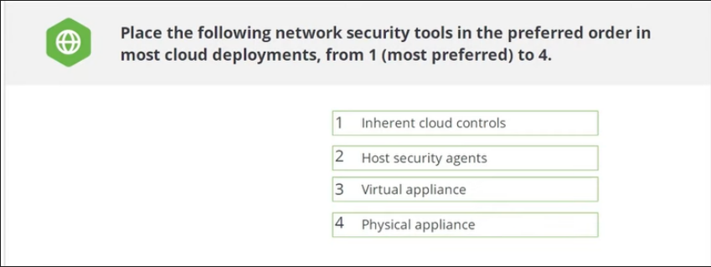

What is the purpose of a bastion network/transit VPC?

**To better support multiple virtual networks and accounts in hybrid scenarios**

To better lock down a hybrid cloud

To create a cloud DMZ

To improve internal routing and IP address space availability

Which of the following is primarily a responsibility of the cloud provider?

Configuring security groups

**Securing the underlying virtualization technology\*\***

Correct configuration in the management plane

Designing subnets, virtual networks, and ACLs2

Of the following, which is the most important use case for the Software Defined Perimeter?

To secure hybrid networks

To encrypt SDN traffic

For federated network identity

**To improve and secure remote access**

Which of the following are cloud workloads? Select all that apply:

Host servers

**Containers**

**Virtual machines**

**Serverless/Function as a Service**

Click on the pipeline component that executed security tests and builds images:

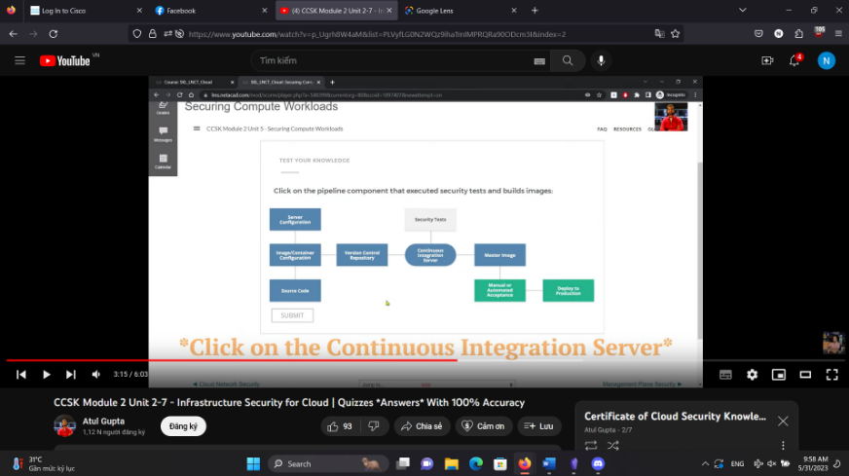

Which of the following most controls when applied to cloud impacts traditional workload

security deployments?

Hypervisors

Serverless

Low resiliency

Security groups

**High volatility/rates of change**

How can immutable workloads improve security?

**They eliminate error-prone manual management**

They scale for DDOS

They better meet performance requirements

They better support use of traditional security tools

Select the cloud workload security option that can most improve overall security and reduce attack surface:

Select cloud aware host security agents

**Use immutable as much as possible**

Store logs external to instances

Leverage existing/traditional vulnerability assessment tools

Which of the following is primarily a cloud consumer workload

security responsibility?

Underlying infrastructure security

Hypervisor security

Volatile memory security

**Monitoring and logging**

Why is management plane security so critical?

**Compromise of the management plane potentially compromises all cloud assets**

REST APIs are inherently insecure.

It is the primary integration point for hybrid cloud.

It is the best way for cloud consumers to protect themselves from hostile cloud provider

employees.

Select the best option for authenticating to a cloud API

**HTTP request signing**

Username/password

Biometrics

TLS-MA

Click and drag the management plane security steps to the correct order

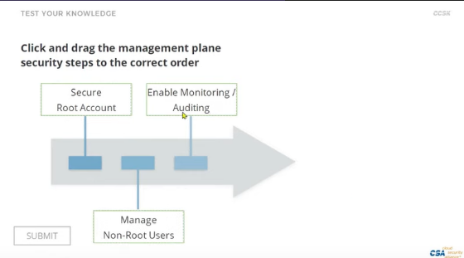

Multi factor authentication is the single most important management plane security control.

**True**

False

Identify one drawback to managing users in the management plane:

Insufficient MFA support

The reliance on RBAC

**High variability between cloud providers**

Lack of SSO support

What is the role of a service administrator?

**To administer cloud platform/management plane users.**

To isolate application security

To administer a limited set of cloud services

They are the core administrators for a cloud account

Select the best option for management plane monitoring, when it is available:

**Inherent cloud auditing, since it captures the most activity**

Inherent cloud auditing, since that offloads responsibility to the cloud provider

Proxy-based auditing, since it eliminates the need to trust the cloud provider

Proxy-based auditing, since it captures more activity

What is the single most important rule for cloud BC/DR?

Use object storage for backups

Snapshot regularly

Use multiple cloud providers

**Architect for failure**

Which is not a key aspect of cloud BC/DR?

Continuity within the provider/platform

**Hypervisor resiliency**

Portability

Preparing for provider outages

Click on the logical model layer that is most difficult to enable for DR across cloud providers.

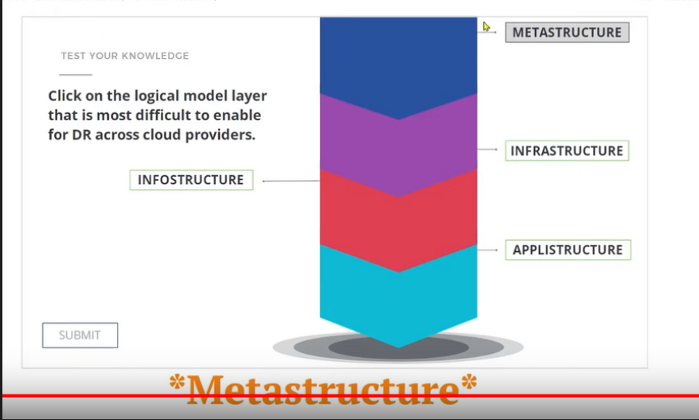

Select a technique to manage continuity within the cloud provider.

Data portability

Multi-cloud provider plans

Hybrid cloud backup

**Cross-location/region design**

Select the governance tool that is most affected by the transition to cloud computing:

Mission statement

**Compliance reporting**

Board of director reporting

Chart of accounts

In terms of cloud computing and security... what is the primary governance role of a contract?

Regulatory requirements

**Defines how you extend internal controls to the cloud provider**

Cost management

To define the data custodian

Does the shared responsibilities model define the contract or the contract define the shared responsibilities model?

The shared responsibilities model defines the contract

**The contract defines the shared responsibilities model**

What is the responsibility of information risk management?

**Align risk management to the tolerance of the data owner**

O Manage overall risk to the organization

Determine the overall risk of cloud providers

Eliminate all risks to information assets

Your risk assessment effort should be equal for all information assets

True

**False**

In which service model does the cloud consumer have to rely most on what is in the contract and documented to enforce and manage security?

PaaS

Hybrid

laaS

**Saas**

Under which conditions is managing risk similar for public and private cloud?

No conditions; public cloud is always riskier

The risk profiles are always the same

**When your private cloud is third party hosted and managed**

When using a major public cloud provider

What is critical when evaluating a cloud service within your risk management program?

Ensuring the provider's security program supports your existing on-premise tools

**Accounting for the context of the information assets involved**

Minimizing regional harm

Eliminating all outsourcing risk

How can you manage risk if you can't negotiate a contract with the cloud provider?

**Use compensating controls and your own risk mitigation mechanisms**

Always choose a different provider

Obtain cyberinsurance

Accept all potential risks

Audits are only used to meet government regulatory requirements.

True

**False**

Cloud changes compliance. Select the statement that is incorrect:

There may be a greater reliance on third party audits

**The cloud provider is ultimately responsible for their customer's compliance**

There are large variations between the compliance capabilities of different cloud providers

Metastructure/management may span jurisdictions even if data is localized

Which is *not* a source of compliance obligations?

Contracts

**Internal Audits**

Legislation

Industry Standards

Compliance inheritance means that an application built on top of a cloud provider's service that is compliant with a regulation/standard is always guaranteed to be compliant.

True

**False**

The Cloud Security Alliance Security Guidance provides:

Legal Guidance

**Information you should discuss with your attorneys.**

Legal Recommendation

Legal Advice

The Australian Privacy Act of 1988 can apply to Australian customers, even if the cloud service provider is based elsewhere:

**True**

False

What is the purpose of a data localization law?

**To require that data about the country's citizens be stored in the country**

To require service providers to register with the country's data protection commission

To require company to hire only local workers

To require that all business documents be in the country's official language

Which of the following is correct?:

GDPR Stands for "Government Data Privacy Rule".

GDPR Establishes fines of $1,000 per credit card number compromised

**GDPR prohibits the transfer of personal data outside the EU or EEA to a country that does not offer a similar privacy rights**

GDPR requires that EU member state's national laws impose network requirements on operators of essential services

The Federal Government in the United States does not directly address issues of data privacy, but instead leave it up to the states to create laws that address privacy concerns:

True

**False**

If a business is located outside the European Union it does not have to comply with the privacy laws of the European Union

True

**False**

In the United States, only entities that collect or process financial data or health data must comply with privacy or security laws

True

**False**

Which of the following is a standard?

ΑΡΡΙ

COPPA

**PCI DSS**

GDPR

When selecting a cloud provider, if a provider won't negotiate a contract:

Always choose another provider

**Read the contract carefully, and consult with your advisors, to evaluate the terms and understand the potential risks.**

Always trust the provider

Contracts are not enforceable in cloud due to the wide range of jurisdictions

Cloud consumers are ultimately responsible for understanding the legal implications of using a particular cloud provider and service.

**True**

False

A contract with a cloud service provider can fulfill all of the following except one

Clarify what happen when the service is terminated

Clarify whether metadata can be reused for secondary purposes

Clarify the price for the service

Define the minimum security measures taken by the cloud provider

**Prevent a breach of security**

If you own the data, it is still possible for your CSP to own the metadata:

**True**

False

Why do cloud providers typically limit their customers' ability to directly assess and inspect their facilities and services?

They are worried customers will find vulnerabilities and they will lose business

Cost management

**On-site inspections can be a security risk, and remote assessments are hard to distinguish from real attacks**

Do deter paying out bug bounties

Audit scopes for any given standard, like an SSAE16 are always consistent.

True

**False**

Select all the following sources that are considered artifacts of compliance

**Activity reports**

**System configuration details**

**Log files**

**Change management details**

Should you assess or review the audits of a cloud provider more or less frequently than traditional outsourcers?

**More**

Less

Which CSA tool maps cloud security control specifications to architectural relevance?

STARWatch

**Cloud Controls Matrix**

The Security, Trust and Assurance Registry (STAR)

Consensus Assessment Initiative Questionnaire

You are a cloud provider and struggling to respond to a large amount of highly variable customer RFP requests for security controls documentation. Which CSA document could you instead complete and send to customers:

Cloud Controls Matrix

STARWatch

The Security, Trust and Assurance Registry (STAR)

**Consensus Assessment Initiative Questionnaire**

Where can cloud providers publish their CAIQ and other security/compliance documents to help cloud prospects and customers assess the provider's current security posture?

**The Security, Trust and Assurance Registry (STAR)**

The AWS marketplace

The United States Federal Register of Cloud Providers

Google

Which CSA tool allows you to quickly search a providers assessment for controls that map to regulations you care about and see the responses to those controls?

CCM

CAIQ

STAR

**STARWatch**

The CSA Cloud Controls Matrix v3.0.1 maps control specifications to FedRAMP High Impact Level.

True

**False**

The CSA Cloud Controls Matrix v3.0.1 contains how many control specifications?

57

16

**133**

295

All cloud data is eventually stored on a physical device, like a hard drive.

**True**

False

Which of the following cloud data storage types can be described as "a database for files":

**Object storage**

Database storage

Volume storage

Platform storag

Why dwe use data dispersion in cloud computing?

Timprove resiliency by eliminating the need for physical drives

Timprove security by obviating the need for encryption

**Time prove resiliency in case of individual drive failure**

Timprove security by reducing the chances a complete file can be stolen

Which security tool can help detect sensitive data migrating the cloud?

Data security proxies (DSP)

Firewalls

**Data Loss Prevention (DLP)**

IPS

Which of the available CASB modes is most cloud-native but often not supported by smaller, especially SaaS, providers:

Ο **ΑΡΙ**

Inline (cloud)

Inline (local)

Cloud-integrated

Which is the preferred model of protecting data migrating the cloud:

Encryption proxies, because they are the most efficient

Encrypting network connections, since you can't trust file encryption

Encrypting files, since you can't trust network encryption

**All are equally effective**

How does cloud complicate access controls as compared traditional

data storage?

There is difference; they are not more complicated

**Cloud storage may offer more options, such as sharing privileges or access the data's metadata**

Cloud access controls are less reliable

All providers must support the same access controls, which makes building the cloud more

Complex

In a Cloud Computing Environment, what is always your most significant security control?

Encryption controls.

**Access controls**

Provider-specific controls

Management controls

Select the 3 components of an encryption system.

Protocol

**Encryption engine**

**Key**

**Data**

In "externally managed" encryption, which is the key component that should be kept externally time prove security:

**Key management**

Data

Encryption Engine

Application code

Instance managed encryption is:

Your preferred option for volume encryption

**An example of what not do**

Which of the following options encrypts data before you transfer it object storage:

Externally managed encryption

Application encryption

Server-side encryption

**Client-side encryption**

Select all *potential* options for encrypting data in PaaS, if they are supported by the platform:

**Database**

**Application-level (in your own code)**

**Provider-integrated**

Volume storage

When using provider managed encryption, you are always sharing the same keys with other tenants.

True

**False**

Proxy-encryption requires you break any existing secure connection your cloud provider:

**True**

False

In the diagram below, what area shows the greatest reduction in attack surface?

**Network attack paths**

The cloud provider

The data center

Application logic attacks

For cloud, where is DLP often best integrated?

Secure Web Gateway

NGFW

The cloud virtual network/VPC

**CASB**

What is the primary goal of data masking?

Stop hackers

**Generate test data that still resembles production data**

Hide production data from employees

Turn test data back introduction data

Logs of some events in a cloud environment may not be available you depending on your choice of cloud provider.

False

**True**

Which is the most inherently secure key management option, but it may not be viable or even needed depending on your project requirements and platform/provider support:

Virtual Appliance

Third-Party Service

Cloud Provider Service

**HSM/Appliance**

The considered Bring Your Own Key (BYOK) the provider must not be able ever see or manage your keys:

**False**

True

Which key management option should you select if you are dealing with highly sensitive data that you don't want your provider potentially access under any circumstances:

Virtual appliance

BYOK

3rd party key management service

**HSM/hybrid**

Which option allows you use an existing build for key management without replicating everything in the cloud?

Third-party Service

**Hybrid**

Virtual Appliance

HSM/Appliance

How should the data security lifecycle be used?

create granular documentation for all sensitive data in the cloud.

create granular documentation for all data, sensitive or not, in the cloud.

replace existing data security architectures.

**As a lightweight tool better understand data flow and potential vs. desired data usage.**

Why we map locations and access?

know when force users use a VPN

replace data flow diagrams

**understand where data flows, in what phases, and how it might be accessed (e.g. devices)**

find the security boundary between internal and external

What is the primary objective of mapping functions, actors, and locations?

list all potential security controls

Replace data flow diagrams

**determine what's possible vs. what should be allowed**

document information risk

What we use reduce what is possible what should be allowed within the context of the lifecycle?

Entitlement matrix

CASB or DLP

Key management

**Security controls**

When moving to cloud, what now becomes within the scope of application security unlike with traditional infrastructure?

**Management Plane**

SAST

Source code

Architecture

STRIDE is a common thread modeling framework. Which of the four categories does a cloud provider typically take more responsibility to manage:

Information disclosure

Spoofing

**Denial of service**

Privilege escalation

What is one example of a control that can reduce the potential of spoofing:

Encryption

**Authentication**

Audit logging

Authorization

Specific testing techniques are tightly aligned and should only be performed during their designated phase in the secure software development process:

True

**False**

Which kind of test should be added to static analysis for cloud deployments?

Regression tests

API resiliency

Code completion

**Scanning for stored cloud credentials**

Which kind of testing will most likely require permission from your cloud provider before performing?

**Vulnerability assessment**

Security unit tests

SAST

Composition analysis

Which vulnerability analysis option will always comply with the terms of service of the cloud provider, but may require paying close attention to network architecture:

Penetration testing

Traditional network-based

**Host based**

Deployment pipeline testing

While there are many definitions of DevOps, one technology/process is typically considered to be central to any DevOps program. Which technology is that?

**Continuous integration**

Configuration management

Composition management

Static analysis

Identify the core security benefit of immutable:

It fully isolates operations from production environments

It fully isolates developers from production environment

All security updates are automatically applied

**There are no manual changes, so everything is consistent and administrative access can be disabled.**

Which of the following are security benefits of DevOps?

**Greater Standardization**

**Automated Testing**

**Improved Security Operations**

**Improved Auditing**

Which of the following is not a new concern of secure operations for applications in the cloud?

WAF limitations/differences

The cloud configuration

**SAST**

The management plane

Which of the following is an inherent architectural security advantage of cloud?

The management plane

**Segregation**

Containers

12 factor applications

How can serverless improve security?

Through automation

**Some attack surface is the responsibility of the cloud provider in the shared responsibilities model**

Better visibility due to the management plane

Serverless actually reduces security

Many of the new architectural options for cloud offer security benefits over what is possible in traditional infrastructure:

**True**

False

What could an email address be considered?

Entity

Identifier

**Identity**

Authorization

What is the technical definition of authentication?

Allowing a user to perform an action

**The process of confirming an identity**

Providing a user access to a resource

The process of validating an entity

What is the defining characteristic of federated identity?

It's supports government identity management

It allows a user to manage multiple identities for a single system

It can manage an identity within a given application

**It inserts an identity across different systems or organizations**

Which of the following is a discrete type that will have an identity? Examples include users and organizations.

Persona

Attributes

**Entity**

Role

What is the biggest difference between IAM in cloud and in traditional environments?

**IAM Must span at least two organizational boundaries**

Cloud is more secure

They use different standards

Cloud is less secure

Which IAM standard is best suited for enterprises federating with cloud providers?

**SAML**

XACML

Kerberos

OATH

Which of the following is one of the 3 most common identity standards in cloud environments?

SCIM

**OATH**

Kerberos

XACML

In a hub and spoke model, which technology mediates between directory servers/identity providers and the service providers/relying parties:

**Federated identity brokers**

Attribute services

CASB

Directory servers

Which of the following IAM security incidents is more likely in cloud versus traditional infrastructure and requires a dedicated incident response focus?

**Account takeover**

Account abuse

Privilege escalation

Pass the hash

Multifactor authentication is absolutely mandatory for cloud computing due to the higher potential for remote account takeovers.

**True**

False

Checking to see if a user authenticated with MFA from a corporate IP address to authorize an action is an example of?

Multifactor authorization

Authentication

Role-based access controls

**Attribute based access controls**

What is an entitlement matrix used for?

**To document authorizations**

To communicate security controls to a cloud provider

To map the directory servers to the appropriate cloud provider

To translate physical security controls to cloud controls

Why are elasticity and infrastructure templating critical IaaS security capabilities?

They improve scalability

They optimize performance

These are operational capabilities, not security capabilities

**They enable immutable deployments.**

Which of the following protocols should a SaaS provider support to help extend an enterprises existing user management security controls and is considered a critical security capability?

AuthZ

LDAp

**SAML**

IPV6

Why are reviewable audits important when evaluating a cloud provider?

Third party auditors provide better results than internal auditors

They will meet all regulatory and compliance standards

They fill the gaps in any cloud provider security documentation

**They provide third party validation when you cannot audit a provider yourself**

Frequent audits and assessments are important when looking at a cloud provider due to how rapidly they evolved their services

**True**

False

Select all of the following characteristics that are required for something to be considered Security as a Service:

It has a hosted web interface

**It meets the NIST essegtial characteristics**

It is built on a IaaS provider

**It is a security product or service delivered as a cloud service**

It is marketed as SecaaS

Which of the following is one of the more unique potential benefits of Security as a Service:

Transparency

Compliance

Customer visibility

**Intelligence Sharing**

Why are regulation differences a potential concern of using Security as a Service?

**The cloud consumer may have regulatory obligations the SecaaS provider can't meet**

SecaaS is unregulated

SecaaS is highly regulated

The cloud provider may have regulatory obligations the customer can't meet

Using SecaaS removes accountability for the client, but only for the particular security control the service addresses.

True

**False**

What characteristic would make a Federated Identity Broker be considered SECaaS vs. a traditional tool?

It supports SAML

It supports multiple cloud providers AND on premise directories

It brokers authentication to cloud services

**It is hosted in the cloud, elastic, and you pay per user**

**What is a potential advantage of a web security gateway SECaaS over an on-premise tool?**

Supports HTTPS

They are always less expensive

It will generally catch more malware

**You can protect mobile users without requiring a VPN to the corporate network**

**What is required to redirect traffic to a cloud WAF?**

An on-premise proxy

GRE tunneling

A VPN

**DNS changes**

**Can a cloud-based key management service be integrated with on- premise encryption?**

No

**Yes**

**If an attacker compromises one of your virtual machines, and then uses it to attack other clients on the same cloud platform, what is the cloud provided s likely action?**

The CSP will prioritize defending the rest of your deployment from the attack.

**The CSP will first protect the rest of their broader clients, which may mean disrupting**

**your deployment**

The CSP will prioritize alerting you and providing information needed for you to

respond to the attack.

The CSP has no responsibility in this situation per the shared responsibilities model.

Click and drag the incident response phases in the proper order.

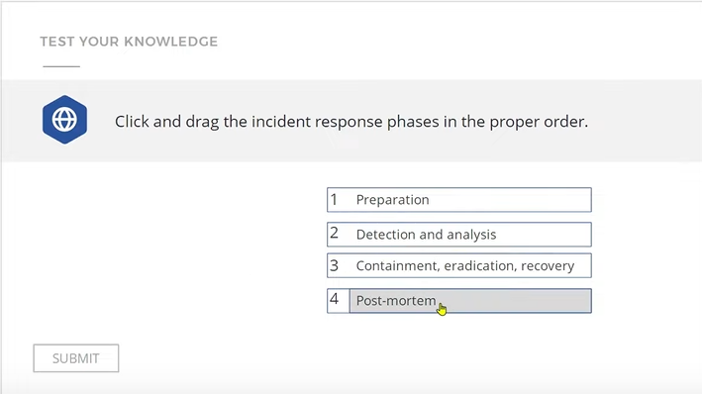

In which phase would you build a cloud "jump kit" of tools and code to speed a response?

Detection and analysis

Containment and response

Postmortem

**Preparation**

In which phase would you snapshot a virtual machine for forensics?

Preparation

**Detection and analysis**

Postmortem

Containment and response

Which of the following most helps you quickly build parallel infrastructure, so that you can rapidly restore operations while still having the compromised environment for analysis?

Snapshots

**Infrastructure as code templates**

PaaS

SaaS

In a postmortem what would be your highest priority to review and remediate if it was a blocker in your incident response?

Operating system vulnerabilities

Internal communications

**Communications with the cloud provider**

Container vulnerabilities

Which of the following is not considered a related technology?

Mobile Computing

Internet of Things

Serverless

**Security as a Service**

Big Data is often defined as "high volume, high velocity, and high variety". What does "high velocity' mean?

Fast raw storage speeds

Storage elasticity

Fast transfer speeds

**The data changes constantly/rapidly**

**Why should you consider relying extensively on the isolation capabilities of cloud to defend a big data deployment?**

The distributed storage is always isolated by nature

**Big data platforms tend to have low inherent security**

Isolation improves encryption

To meet compliance requirements

While not directly related to cloud, which IoT principle is critical for long-term security?

Data encryption

**The ability to patch/update the "things" (devices)**

Elasticity

Public APIs

Which of the following issues on a mobile device can actually create security risks for the cloud deployment?

Insecure wireless networks

**Embedded/static/stored credentials**

A malicious app

Use of an out of date operating system

Serverless, used properly, can offer more security benefits than risks.

**True**

False